1. Find the normalizing constant analytically

For any normal distribution, we have the probability density integrated to 1, which is

$$\int_{-∞}^{∞}{\frac{1}{\sqrt{2πσ^{2}}}e^{\frac{-{(θ-μ)}^{2}}{2σ^{2}}}}dθ=1$$

Make σ=1,

$$\int_{-∞}^{∞}{e^{\frac{-{(θ-μ)}^{2}}{2}}}dθ=\sqrt{2π}$$

Now Consider

$$π\left(θ\right)∝e^{\frac{-θ^{2}}{2}}+0.5*e^{\frac{-{(θ-3)}^{2}}{2}}$$

Let the normalizing constant be c, we then have

$$π\left(θ\right)=c\{e^{\frac{-θ^{2}}{2}}+0.5*e^{\frac{-{\left(θ-3\right)}^{2}}{2}}\}$$

Since

$$\int{π\left(θ\right)dθ=1}$$

We have,

$$\int{π\left(θ\right)dθ=}\int{c\{e^{\frac{-θ^{2}}{2}}+0.5*e^{\frac{-{\left(θ-3\right)}^{2}}{2}}\}}dθ=c\int{e^{\frac{-θ^{2}}{2}}dθ}+0.5*c\int{e^{\frac{-{\left(θ-3\right)}^{2}}{2}}dθ}$$

$$c*\left(1+\frac{1}{2}\right)*\sqrt{2π}=1$$

Consequently,

2. Metropolis Hasting Sampling- Choose such σcand that the acceptance probability is very close to 45%.

$$θ^{*}\sim N(θ^{*}|θ,σcand)$$

$$r=\frac{π(θ^{*})}{π(θ^{(t-1)})}$$

Using the attached Code we can calculate the acceptance rate.

|  |  |  |  |  |  |
| --- | --- | --- | --- | --- | --- |
| σcand | 1 | 3 | 4 | 5 | 100 |
| Accept. Rate | 79.4% | 51.58% | 44.46% | 36.7% | 2.14% |

We know, when σcand=4, the acceptance is most close to 45%. The corresponding plot of theoretical and sampled density is:

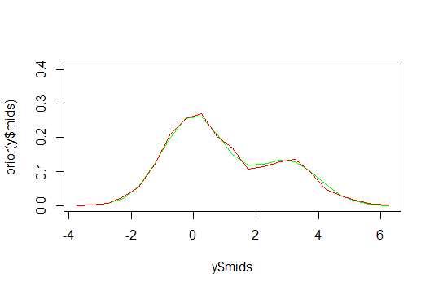

Green: Theoretical

Red: MH-Sampler

3. In theory, what’s wrong with using σcand=0.05? Is there anything wrong in practice? Do your answers change for σcand=8? What about for σcand=100? Please be specific.

The trace plot of theta when σcand=4 is shown below:

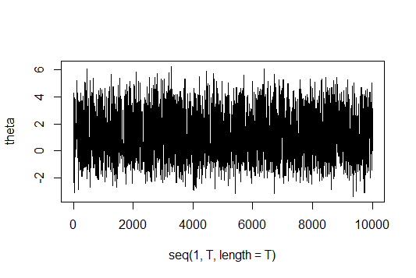

Compare to the trace plot of theta when σcand=0.05, which is:

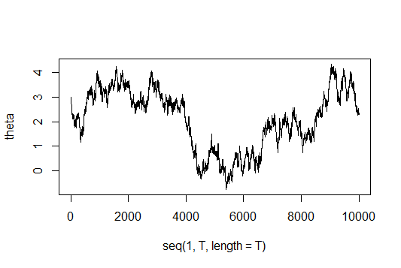

We can see, σcand is too small, when acceptance rate is high as 99.9%, resulted in a lot of waste in computation. More importantly, the sample result is bad, as shown in the below plot:

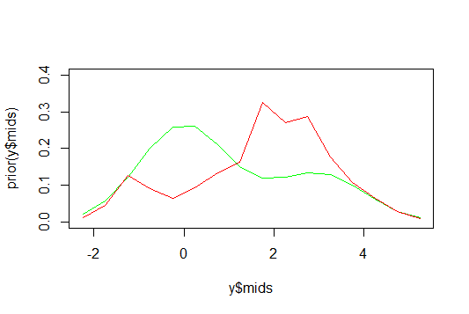

Green: Theoretical

Red: MH-Sampler

When σcand=8, acceptance is 25.5%, which has a reasonable trace plot and simulation of density of theta.

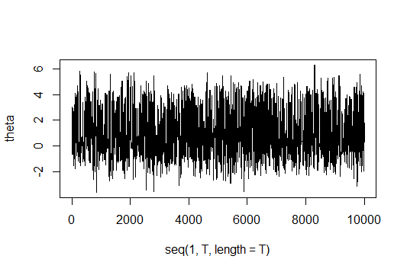

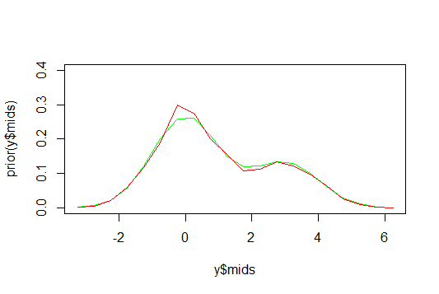

Green: Theoretical

Red: MH-Sampler

However, when σcand=100, the acceptance rate is only 2.5%, which resulted in a trace plot of theta like below:

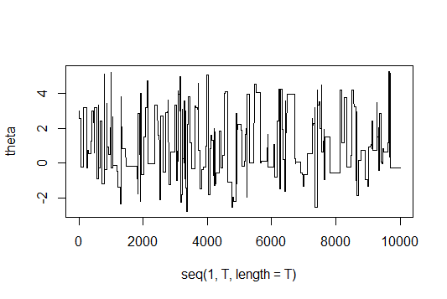

The consequence is that the sampled density plot does not represent the theoretical well enough.

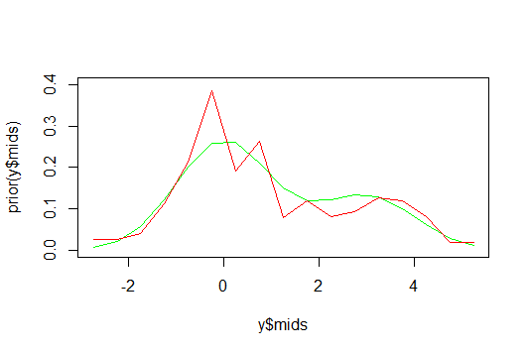

Green: Theoretical

Red: MH-Sampler

#######Code#############

#######2##########

T=10001;sigma.cand=4

theta=matrix(nrow=1,ncol=T)

theta.star=matrix(nrow=1,ncol=T)

r=matrix(nrow=1,ncol=T)

theta[1]=3

acceptance.count=0

prior <- function(theta) {

z <- 2/(3*sqrt(2*pi))*(exp(-1*0.5*theta^2)+0.5*exp(-1*0.5*(theta-3)^2))

return (z)

}

for (i in 2:T) {

theta.star[i]<-rnorm(1,theta[i-1],sigma.cand)

r[i] <- prior(theta.star[i])/prior(theta[i-1])

u <- runif(1,0,1)

if (u< min(1,r[i])) {theta[i] <- theta.star[i]

acceptance.count=acceptance.count+1}

else {theta[i] <- theta[i-1]}

}

Acceptance.Rate <- acceptance.count/(T-1)

y <- hist(theta,plot="false")

plot(y$mids,prior(y$mids),type="l",col="green",ylim=c(0,0.4))

lines(y$mids,y$density,type="l",col="red")

##############3########

###Trace Plot

plot(seq(1,T,length=T),theta,type="l")